**English 2201 Visual Review**: For each of the following visuals, state a theme and support your theme using TWO visual elements.

#1



#2

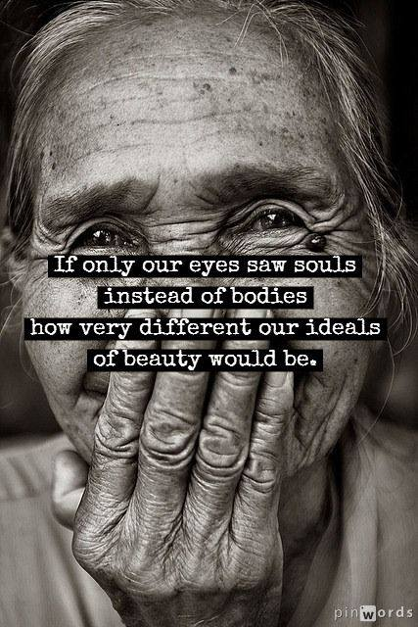

#3

